Q1. Create a New Database and Table for Employees

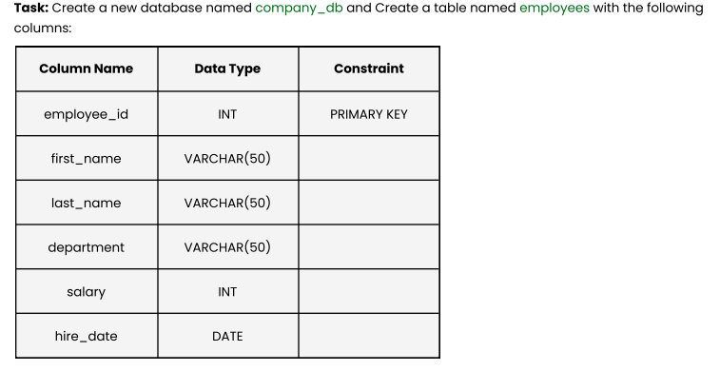
Answer,

-- Create the database

CREATE DATABASE company_db;

-- Select the database to use

USE company_db;

-- Create the employees table

CREATE TABLE employees (
employee_id INT PRIMARY KEY,
first_name VARCHAR(50),
last_name VARCHAR(50),
department VARCHAR(50),
salary INT,
hire_date DATE);

Q2. Insert Data into Employees Table

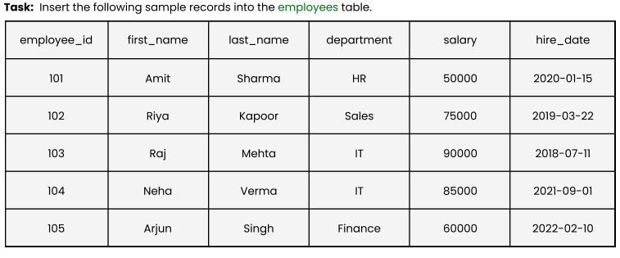
Answer

INSERT INTO employees
VALUES
(101, 'Amit', 'Sharma', 'HR', 50000, '2020-01-15'),
(102, 'Riya', 'Kapoor', 'Sales', 75000, '2019-03-22'),
(103, 'Raj', 'Mehta', 'IT', 90000, '2018-07-11'),
(104, 'Neha', 'Verma', 'IT', 85000, '2021-09-01'),
(105, 'Arjun', 'Singh', 'Finance', 60000, '2022-02-10');

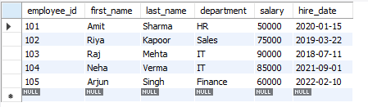

Q3. Display All Employee Records Sorted by Salary (Lowest to Highest)

Display all records ordered by the salary column in ascending order.

SELECT * FROM employees
ORDER BY salary ASC;

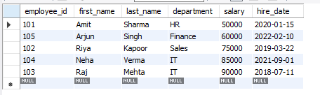

Q4. Show Employees Sorted by Department (A–Z) and Salary (High → Low)

Sort employees by Department (A-Z) first, and then by Salary (High $\rightarrow$ Low) within those departments.

SELECT * FROM employees
ORDER BY department ASC, salary DESC;

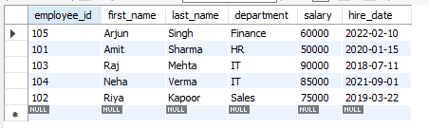

Q5. List All Employees in the IT Department, Ordered by Hire Date (Newest First)

Filter for the 'IT' department and order by hire date, starting with the most recent.

SELECT * FROM employees
WHERE department = 'IT'
ORDER BY hire_date DESC;

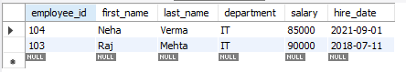

Q6.Create and Populate a Sales Table

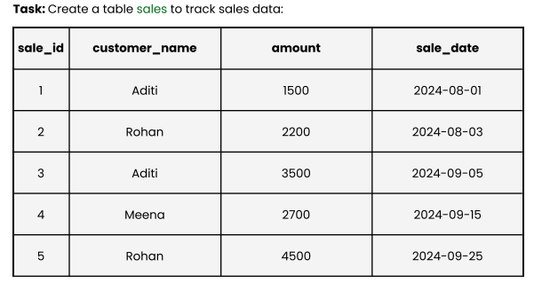

Create a sales table and insert the tracking data provided. Note that the source data mixes the order of "amount" and "customer_name" visually, which has been standardized below.

-- Create the sales table

CREATE TABLE sales (
sale_id INT PRIMARY KEY,
amount INT,
customer_name VARCHAR(50),
sale_date DATE);

-- Insert the sales data

INSERT INTO sales (sale_id, amount, customer_name, sale_date)
VALUES
(1, 1500, 'Aditi', '2024-08-01'),
(2, 2200, 'Rohan', '2024-08-03'),
(3, 3500, 'Aditi', '2024-09-05'),
(4, 2700, 'Meena', '2024-09-15'),
(5, 4500, 'Rohan', '2024-09-25');

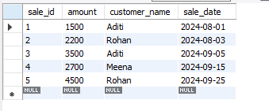

Q7. Display All Sales Records Sorted by Amount (Highest → Lowest)

Display all sales records ordered by amount in descending order.

SELECT * FROM sales
ORDER BY amount DESC;

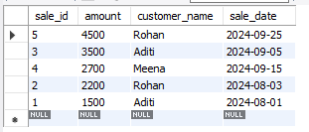
Q8. Show All Sales Made by Customer “Aditi”

SELECT * FROM sales
WHERE customer_name = 'Aditi';

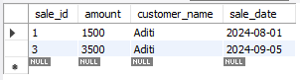
Q9. Difference Between Primary Key and Foreign Key

Primary Key (PK): A column (or set of columns) that uniquely identifies every row in a table. It cannot contain NULL values and must be unique for every record (e.g., employee_id in my table).

Foreign Key (FK): A column that links data in one table to the Primary Key in another table. It enforces referential integrity, ensuring the relationship between the two tables remains valid.

Q10. What are Constraints in SQL?
Constraints are rules applied to table columns to restrict the type of data that can go into the table. They ensure the accuracy and reliability of the data. Common examples used in your document include:
- PRIMARY KEY: Ensures uniqueness.
- NOT NULL (implied in PK): Ensures a column cannot have a null value.
- Data types (like INT or VARCHAR): Restrict the format of the data.

